Module 1.3 Assignment: On the Wall + Flowchart
Name: Jordan Dardar
Assignment Number: Module 1.3
Flowchart
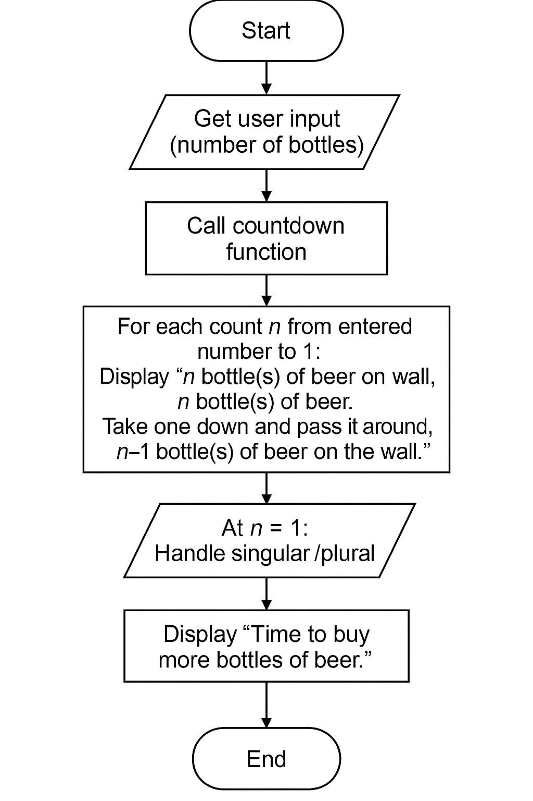
Flowchart of beer countdown
The flowchart above illustrates the algorithm for the “100 Bottles of Beer on the Wall” countdown program. It begins by prompting the user to enter the number of bottles and then calls a countdown function. Inside the function, a loop counts down from the entered number to 1, printing the lyrics of the song and adjusting for singular/plural grammar when there is only one bottle left. After the loop, the program reminds the user to buy more beer.
Python Program
The following Python script implements the logic described in the flowchart. You can copy and paste this code into PyCharm or another Python editor and run it.
def countdown_bottles():
# Ask user for input and validate
while True:
try:
bottles = int(input("Enter number of bottles: "))
break
except ValueError:
print("Invalid input. Please enter an integer.")
# Loop from entered number down to 1
for n in range(bottles, 0, -1):
if n == 1:
# Singular case for one bottle
print(f"{n} bottle of beer on the wall, {n} bottle of beer.")
print("Take one down and pass it around, no more bottles of beer on the wall.\n")
else:
# Plural case for two or more bottles
print(f"{n} bottles of beer on the wall, {n} bottles of beer.")
next_bottles = n - 1
bottle_word = "bottle" if next_bottles == 1 else "bottles"
print(f"Take one down and pass it around, {next_bottles} {bottle_word} of beer on the wall.\n")
# After loop, remind user to buy more
print("Time to buy more bottles of beer.")
if __name__ == '__main__':
countdown_bottles()
This script asks the user how many bottles are on the wall, counts down from that number to 1 while printing the appropriate lyrics, handles singular and plural grammar, and then prints a reminder to buy more bottles of beer.

